Group name: "Blue Devils"

We are a team of 4 members, **Lavanya Mattaparthi, Kruthika UmmadahalliSomaraju, Harshita Singh** and **Khanom Meshkat Hassan Beiki.** Our team is good at problem solving, and they are Quick learners and hard workers.

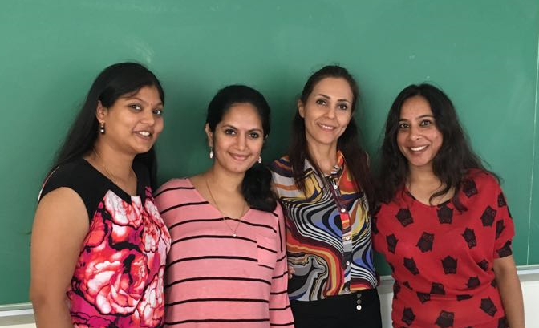

Let’s take a moment to introduce each individual in our team.

**Lavanya Mattaparthi**

|  |  |
| --- | --- |
|  | Lavanya Mattaparthi grew up in Amalapuram, India and completed her bachelor's in ***Electrical and Electronics Engineering*** from ***BVC institute of technology and science*** with distinction in 2013. In her academics, she presented a project titled “***Secured Power Transmission with loss analysis***”, the project grabbed the attention of my professionals leading it to be one of the best projects in that year. Later she joined as a faculty in ***RMJ automation and training Pvt.ltd*** . Currently, she is pursuing masters in computer information technology with computer science as major expected to graduate in May 2017, in her curriculum, she gained knowledge on JAVA, C and Data structures, HTML, and Networking methodologies. |

**Kruthika UmmadahalliSomaraju**

|  |  |
| --- | --- |
|  | Kruthika UmmadahalliSomaraju is a student at CCSU pursuing MS in computer information technology with computer science as major expected to graduate in May 2017, she was born in Mandya (India) and did her schooling in ***Carmel convert high school*** and graduated from ***Viswevariah Technological University*** at Bangalore (India) with a Bachelor of Engineering in May 2008. She later worked as a software tester in ***Target Corporation*** and worked on many HR applications like PeopleSoft, SAP, Workforce Management, etc. In her curriculum, she gained good knowledge on Java, Database Systems, Algorithms, Web Programming which are her favorite topics. |

**Harshita Singh**

|  |  |
| --- | --- |
|  | Harshita Singh is a student of MS-CIT program and currently in her third semester. She is working On-Campus as a ***Graduate Assistant*** under Chairman Peter Bauman in the Engineering department. She is an International student from India and done her graduation in ***Commerce*** and Masters in ***MBA***. To gain the technical knowledge she is currently pursuing her double Master’s in Computer Science and so far she has learnt java, database, data structures, networking concepts, etc. Earlier she was working as a ***SAP consultant*** in an IT company based in India. Her goal is to work with the employee-centric IT giants like Google, Microsoft, where she can use her technical and management skills. She is a hard-working and self-motivated person who focuses on converting her dreams into reality. |

**Khanom Meshkat Hassan Beiki**

|  |  |
| --- | --- |
| image1 | Khanom Meshkat Hassan Beiki was born in Tehran, Iran, in 1974. She landed in United State on Oct 2013 along with her daughter. She completed bachelor's in ***Medical Librarianship and Information*** at ***Iran University of Medical Science,*** Tehran, Iran in 1997 and completed masters in ***Medical Informatics & Health Economics*** in the same institute in 2012 and she worked at **Central library of the university** between 1997-2013 as a ***Digital librarian*** and ***reference librarian***. She achieved multiple certifications in computers as well as medical science sector. Currently, she gained knowledge on Java, Data structure, and networking concepts. |

**Our first meeting at cafeteria:**

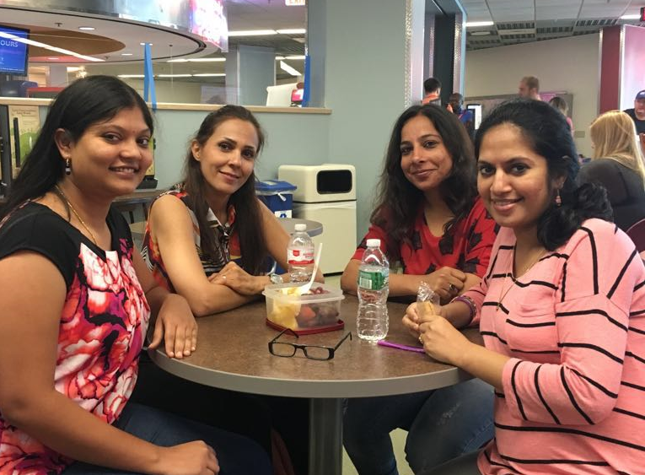

In the meeting, the team discussed a couple of items and came up with a decision.

GitHub ID’s for our team **LavanyaMattaparthi**, **Kruthikaummadahallisomaraju**, **Harshita01** and **Nushinbeigi**

1. Methods of communication

Email: Which allow us to communicate any files and important updates.

WhatsApp: We have made a separate group dedicated to the software engineering project, so we can all Communicate in real time

Face to face: For project status meeting

Phone: For immediate communication

1. Communication response times

Email: Response time would be 3 hours

Text: Maximum 15 mins

Phone: Immediate

1. Meeting attendance

All 4 members will attend the meeting and it will be scheduled twice a week Monday and Wednesday.

We have decided to have these meetings mandatory since this would be our status meeting.

1. Running meetings

We all have agreed to have a meeting at CCSU student center, which will be a face to face meeting because this would make our understanding better. Team member Harshita will take the minutes of the meeting.

1. Meeting preparation

Yes, we feel preparation is very much required before we join for a meeting,

1. Version control

Currently, we haven’t planned for any Version control tools, but any documents and log message will be reviewed by team members before sharing.

1. Division of work

Team member Kruthika will be deciding on who is going to take up what part of the project.

1. Submitting assignments

We make sure that we submit our assignments on time. We all team members review the assignment before the team member Meshkat submit it.

1. Contingency planning

We have planned to move ahead and not to stop our work at any cost if any team member misses meetings or academically dishonest. We have also planned to share the work of the dropout among the rest of the team members